Game Design Document

Fill up the Following document

1. Write the title of your project.

Food Maze

1. What is the goal of the game?

Eating all the food

1. Write a brief story of your game?

Matt, a maze lover, is hungry and wants to eat something junk as he is tired of eating healthy food. As Matt knows you are a coder, he wants you to make a maze game with junk foods to collect.

1. Which are the playing characters of this game?

* Playing characters are the ones which respond to the user based on the input from the user
* Cars, monkeys, dinos, wizards etc, are the playing characters in the game.

|  |  |  |
| --- | --- | --- |
| Number | Character Name | What can this character do? |
| 1 | Matt | Move in all directions to collect food |
| 2 |  |  |
| 3 |  |  |
| 4 |  |  |
| 5 |  |  |
| 6 |  |  |
| 7 |  |  |
| 8 |  |  |

1. Which are the Non Playing Characters of this game?

* Non Playing characters are the ones which don't have an action or a behaviour when the user interacts with the game.
* Hurdles, stones, bananas, coins, etc are non playing characters in the game.

|  |  |  |
| --- | --- | --- |
| Number | Character Name | What can this character do? |
| 1 | Maze bricks | Hurdles which make it tough to collect the food. |
| 2 | French fires | Disappear when touched by Matt |
| 3 | Donut | Disappear when touched by Matt |
| 4 | Pizza | Disappear when touched by Matt |
| 5 | Burger | Disappear when touched by Matt |
| 6 | Juice | Disappear when touched by Matt |
| 7 | Pasta | Disappear when touched by Matt |
| 8 |  |  |

Draw your imagination of this game. What does this game look like?

* Draw the game either on your computer or on paper,
* Add images of scenes of the game to show each of the playing and non-playing characters at least once.

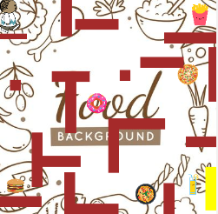 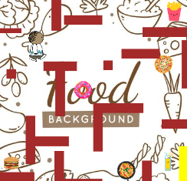 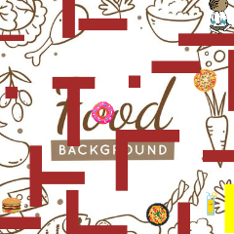

How do you plan to make your game engaging?

By making food disappear when touched by Matt.